**CHAPTER ONE**

**INTRODUCTION**

**1.1 Preamble**

E-leaning describe the development and initial experiences with a web base system, E-learning management system developed and designed to facilitate teachers in the management of educational course for their students, especially by helping teachers and students with course administration. With this system teachers can monitor the progress of their students.

The goal was to create a course management system that includes: course content organization and presentation, communication tools like message board, student assessment tools to help students obtain course material and download and submit assignments and grade book for use of students and department members.

E-learning system can be used to support and organize the work of academic departments, organization and other project also to supervise the work of teacher assistants and students in the field of academic . The most important goal includes providing lecture materials, resources, increasing transparency and getting fast feedback, and increasing contact with and among students.

Database systems are designed to manage large bodies of information, management of data involves both defining structures for storage of information and providing mechanisms for the manipulation of information. In addition, the database system must ensure the safety of the information stored, despite system crashes or attempts at unauthorized access (Siberschatz-Korth-Sudyarshsn ,2004).

Basically, the e-learning system involves execution through the web or the intranet and it reduces the large proportion of workload on learning, class, uploading and reviewing. The course of in the e-learning system are optional that can be formally and easily evaluated online.

Students will be assessed by conducting online objective test. The test would be uniquely customizable and will enable educational institutes to conduct test and have automated checking of answers based on the response by the candidate.

* 1. **Statement of Problem**

The part of the education challenge is that the quality of education received in traditional public and private school do not prepare student for the future, which for the majority does not include university placement. The students of today may require a new and different skillets, different ways of thinking and interacting with information and a different approach to the education system overall to be competitive.

**1.3 Aim and Objectives**

The aim of this project is to develop e-Learning management system for the use of departments in institutions.

The objectives of this project include the following:

* To create facility for department to examine and grade students in the learning process.
* To evaluate the effectiveness of the system compared to traditional learning process.

**1.4 Scope of Study**

The study will focus on a section of 500 level lecture and examination/test conduction in Ladoke Akintola University of Technology, department of computer science and engineering; this project covers design, and practical demonstration.

**1.5 Methodology**

The application will be developed using HTML, PHP, J-QUERY, BOOTSTRAP and MYSQL database for dynamism, and tested on an Apache web server, hosted on the University intranet.

**Definition of Terms**

**EDUCATION**: Education is the process by which an individual is encouraged and enabled to fully develop his or her potential academically.

**EDUCATION TECHNOLOGY**: Educational technology refers to the use of technology in learning.

**E -ASSESSMENT**: e-assessment is the use of information technology for any assessment-related activity.

**CBA**: Computer-Based Assessment refers to assessment which is built around the use of computer.

**ONLINE ASSESSMENT**: Online assessment refers to assessment activity which requires the use of the internet.

**SYNCHRONOUS LEARNING**: Synchronous learning involves the exchange of ideas and information with one or more participants during the same period of time.

**ASYNCHRONOUS LEARNING**: Asynchronous applications include programmed instruction and tutorials that allow students to work through the screens at their own pace and at their own time.

**EPSS**: Electronic performance support systems (EPSS) is as an integrated electronic environment that is available to and easily accessible by each employee and is structured to provide immediate, individualized on-line access to the full range of information, software, guidance, advice and assistance, data, images, tools, and assessment and monitoring systems.

**LMS**: Learning management system (LMS) is software used for delivering, tracking and managing training and education.

**DATABASE ADMINISTRATOR (DBA):** A database administrator is someone responsible for installation, configuration, upgrade, administration, monitoring, maintenance, securing of Databases in an organization.

**MySQL**: MySQL is an open source database used by the many thousands of web applications

**PHP**: PHP provides a way for you to put instructions in your HTML files to create dynamic content. These instructions are read and parsed by the web server; they never actually make it to the browser that is displaying the page.

**CHAPTER TWO**

**LITERATURE REVIEW**

**2.1 BACKGROUND OVERVIEW**

The origin of the term e-Learning is not certain, although it is suggested that the term most likely originated during the 1980's, within the similar time frame of another delivery mode of online learning. While some authors explicitly define e-Learning, others imply a specific definition or view of e-Learning in their article. These definitions materialize, some through conflicting views of other definitions, and some just by simply comparing defining characteristics with other existing terms. In particular, Ellis (2004) disagrees with authors like Nichols (2003) who define e-Learning as strictly being accessible using technological tools that are web-based, web-distributed, or web-capable.

The belief that e-Learning not only covers content and instructional methods delivered via CD-ROM, the Internet or an Intranet (Benson et al., 2002; Clark, 2002) but also includes audio- and videotape, satellite broadcast and interactive TV is the one held by Ellis. Although technological characteristics are included in the definition of the term, Tavangarian, Leypold, Nölting, Röser, and Voigt (2004) as well as Triacca, Bolchini, Botturi, and Inversini (2004) felt that the technology being used was insufficient as a descriptor. Tavangarian et al. (2004) included the constructivist theoretical model as a framework for their definition by stating that e-Learning is not only procedural but also shows some transformation of an individual's experience into the individual's knowledge through the knowledge construction process. Both Ellis (2004) and Triacca et al. (2004) believed that some level of interactivity needs to be included to make the definition truly applicable in describing the learning experience, even though Triacca et al. (2004) added that e- Learning was a type of online learning.

According to *Wikipedia, the free encyclopedia*, e-learning is an inclusive term that describes educational technology that electronically or technologically supports learning and teaching. The environment of higher education is evolving. Rising costs, shrinking budgets, and increasing needs for distance education (New Media Consortium, 2007) are causing educational institutions to reexamine the way that education is delivered. In response to this changing environment, e-learning is being implemented more and more frequently in higher education, creating new and exciting opportunities for both educational institutions and students.

E-learning, or electronic learning, has been defined a number of different ways in the literature. In general, e-learning is the expression broadly used to describe “instructional content or learning experience delivered or enabled by electronic technologies” (Ong, Lai and Wang, 2004, page 1). Some definitions of e-learning are more restrictive than this one, for example limiting e-learning to content delivery via the Internet (Jones, 2003). More recently, this definition can be further expanded to include mobile and wireless learning applications (Kinshuk, Suhonen, Sutinen, and Goh, 2003; Lehner, Nösekabel and Lehmann, 2003).

The e-learning models of higher education today find their roots in conventional distance education. Initially introduced to allow individuals in remote and rural areas to gain access to higher education, distance learning has evolved significantly over time. Technological advancement has been the major inspiration for change, beginning with the integration of radio broadcasting in the 1920’s (Huynh, Umesh and Valachich, 2003). More recently, the advent of the Internet has enabled tremendous innovation in the delivery of post secondary education (Gunasekaran, McNeil and Shaul, 2002; Teo and Gay, 2006). As time goes by, more and more people gain access to the Internet, the cost of computer ownership decreases, and overall computer literacy increases (Huynh et al., 2003). These trends provide educational institutions an ideal channel for the delivery of educational content.

**2.2 Brief history**

In 1960, the University of Illinois initiated a classroom system based in linked computer terminals where students could access informational resources on a particular course while listening to the lectures that were recorded via some form of remotely-linked device like television or audio device.

In the early 1960s, Stanford University psychology professors Patrick Suppes and Richard C. Atkinson experimented with using computers to teach math and reading to young children in elementary schools in East Palo Alto, California. Stanford's Education Program for Gifted Youth is descended from those early experiments. In 1963, Bernard Luskin installed the first computer in a community college for instruction, working with Stanford and others, developed computer assisted instruction. Luskin completed his landmark UCLA dissertation working with the Rand Corporation in analyzing obstacles to computer assisted instruction in 1970. Educational institutions began to take advantage of the new medium by offering distance learning courses using computer networking for information.

Early e-learning systems, based on Computer-Based Learning/Training often attempted to replicate autocratic teaching styles whereby the role of the e-learning system was assumed to be for transferring knowledge, as opposed to systems developed later based on Computer Supported Collaborative Learning (CSCL), which encouraged the shared development of knowledge. Computer-based learning made up many early e-learning courses such as those developed by Murray Turoff and Starr Roxanne Hiltz in the 1970s and 80s at the New Jersey Institute of Technology, and the ones developed at the University of Guelph in Canada. In 1976, Bernard Luskin launched Coastline Community College as a "college without walls" using television station KOCE-TV as a vehicle. By the mid-1980s, accessing course content becomes possible at many college libraries. Cassandra B. Whyte researched about the ever increasing role that computers would play in higher education. This evolution, to include computer-supported collaborative learning, in addition to data management, has been realized. The type of computers has changed over the years from cumbersome, slow devices taking up much space in the classroom, home, and office to laptops and handheld devices that are more portable in form and size and this minimalization of technology devices will continue.

The Open University in Britain and the University of British Columbia (where Web CT, now incorporated into Blackboard Inc. was first developed) began a revolution of using the Internet to deliver learning, making heavy use of web-based training and online distance learning and online discussion between students. Practitioners such as Harasim (1995) put heavy emphasis on the use of learning networks.

Gaytan(2007) presented a detailed historical background of online education, with regards to its current status, its potentials and limitations that could lead to the advancement of the scholarship of teaching and learning. He stressed the need for online instructors to understand the way online education has evolved over the years from previous conceptions of education and the wide array of implications and assumptions involved in the delivery of online education. He also presented some recommendations for the advancement of online education.

M’hammed et al (2007) worked on the challenges in distance learning unit. He observed that inefficient management could lead to a variety of problems in course delivery, such as delays in obtaining textbooks, problems in obtaining copyright permission, and even course delays. In an effort to facilitate, streamline and improve forms management, a system was designed to streamline the management of required forms for face-to-face, hybrid, online and televised courses. The system developed provides faculty, and distance learning administrators with an easy method to manage all forms effectively and efficiently.

The Nigerian Open University (NOU) is a typical example of e-learning platform where lectures are delivered through radio and television broadcast. However, the deployment of very small aperture terminals (VSATs) with video-conferencing was to enhance the performance of NOU project effectively with a view to extending the facilities to the rural dwellers (Oliver, 2003). Osuji (2005) listed the elements of distance learning as print media (print and electronic), occasional face-to-face tutorials between teachers and the involvement of different role players.

The Code NC Examiner is a web application designed for online examinations. The examiner makes it possible to conduct the exams remotely. Lecturers log on to the system and create exam. Exam questions are then stored in the database. When an exam is to be conducted the system would randomly select a predefined number of questions and make them available to student. As the student answers the questions the result is calculated and displayed on score board. Though the application is designed mainly for aptitude test and exams, it can easily be adopted to suit the needs of complex scenarios, depending on the requirements of the client.

Philip Dorell (2006) created a test engine to help student obtained their marks with ease. Users can use the system for writing the test and know about the system functionality. An individual can make use of the system by login in and taking a test. The main aim of carrying out a preliminary investigation is to attain much knowledge about understanding of problem, defining the project scope and constraints, identifying the benefits, estimating the time.

Furthermore, the Nigeria National IT policy, which was formulated in the year 2000, is responsible for the monumental developments across the various sectors of the economy.  The vision is to make Nigeria an IT capable country in Africa and a key player in the information society.  Its primary mission is to “Use IT” for: education; creation of wealth; poverty eradication; job creation; governance; health; agriculture; etc. (Ajayi, 2005). The drive has led to major developments such as the: Mobile Internet Units (MIUs), which include busses equipped with ICT facilities such as PCs, peripheral devices and VSAT which are used to carry ICT education to rural areas; and the WIN Project, tagged “Wire Nigeria”.  It is intended to provide ICT infrastructure to all the nooks and crannies of the country.

**2.3 Dimensions of E-Learning**

The extent of e-learning technology use in course delivery varies widely. The variations in the configuration of e-learning offerings can be described through a number of attributes, as listed in Table 1 below. These attributes can be classified into the dimensions of synchronicity, location, independence, and mode. An e-learning course component can be described by indicating which one of the two attribute values from each dimension is applicable. E-learning can be synchronous (real-time) or asynchronous (flex-time). Synchronous e-learning includes technology such as video conferencing and electronic white boards (RomiszowskiI, 2004), requiring students to be present at the time of content delivery. Asynchronous applications include programmed instruction and tutorials that allow students to work through the screens at their own pace and at their own time. Most of the courses available on the Internet are based on this asynchronous model (Greenagel, 2002). Students can be involved in e-learning from distributed locations, as in distance learning, or from the same place, such as using a group support system in a classroom to work on an assignment (Gunasekaran et al., 2002).

E-learning applications also differ in the levels of collaboration that they involve. Some courses are entirely independent and individual, while others incorporate some elements of group learning such as discussion forums or chat rooms. The mode of course delivery can be entirely electronic (with or without an instructor) or take a more blended approach integrating electronic and classroom delivery to varying extents. Many current e-learning offerings follow the latter mode, taking advantage of the benefits of various types of delivery (Jack and Curt, 2001).

To demonstrate and maintain academic integrity, some institutions require proctor supervision of online exams. However, proctoring can be very expensive. Costs to students can include fees at testing centers, costs to purchase the Remote Proctor, time to find an approved proctor, and effort required to coordinate a time for the exam. Costs to the institution include salaries of staff to administer a proctoring process, approval of proctors, maintaining testing centers, and potential loss of enrollments and revenue since not all institutions require proctors for online exams. This paper examines the control issues related to online exams and asserts that the total cost of proctors for online exams (time and money of both students and the institution) exceed potential benefits. The authors propose a less costly, non-proctor alternative to promote academic honesty, using eight control procedures that enable faculty to increase the difficulty and thus reduce the likelihood of cheating by students. (*Journal of Academic and Business Ethics Thwarting Online Test Cheating, Page 5*)

**2.4 Importance of E-learning and online Examination**

Education in any kind is necessary for man to develop socially and intellectually. Every day we learn something new. An education should be rooted to culture and committed to progress. Each of us has a social personality that is different from everyone else, and learning personality that is different from everyone else. Our learning personality is the combination of natural talent, personal interest, current opportunity, social environment, character and how the brain process information.

In today’s world this learning capability is judged by means of examinations. Examinations are very important in judging ones personality. Thus, the need today of exams in universities, schools, colleges and even companies for recruitment purpose. The general paper-pen tests/exams are now slowly being replaced by the online internet testing system.

Examinations are part of the learning process

1. An element in assessment
2. Stimulus to order thought
3. Helps to think under pressure
4. Satisfaction in knowing that studies are done
5. Helps in judging one’s capability for a career in future

Online examination sometimes referred to as or e-examination are exams conducted through the internet or the intranet (if within the organization) for remote candidate. Most of the examination issue results as the candidates finish the exam, when there is an answer processing module also included in the system. Candidate is given a limited time to answer the question and after the time expires the answer paper disables automatically and answers sent to examiner. The examiner will evaluate answers, either through automated process or manually and the result will be sent to the candidate through email or made available in the website.

2.5 **PHP CONFIGURATION**

PHP is a server-side, HTML-embedded, cross-platform scripting language, quite a mouthful. In simpler terms, PHP provides a way for one to put instructions in an HTML files to create dynamic content. These instructions are read and parsed by the web server; they never actually make it to the browser that is displaying the page. The web server replaces the PHP code with the content that the code was written to produce. PHP can be configured to run either as a server module or as a standalone CGI script. At the time of this writing, the server-module version is only production-ready for the Apache web server on Unix systems. The CGI version runs with all web servers on both Unix and Windows 95/98/NT. On the Windows platform (as of PHP Version 4), the server module is being developed to work with ISAPI, NSAPI, and WSAPI, which means the server module will eventually work with Microsoft's IIS, Netscape's Enterprise Server, and O'Reilly's Website. Cited from [*http://www.php.net*](http://www.php.net).

The PHP language itself borrows concepts from other common languages, such as C and Perl. In addition to the core language, PHP provides a wide variety of functions that support everything from array manipulation to regular expression support.

**2.5.1 BASIC SYNTAX**

A PHP script always starts with <?php and ends with ?>.A PHP script can be placed anywhere in the document. On servers with shorthand-support, we can start a PHP script with <? and end with ?>. For maximum compatibility, it is recommend to use the standard form (<?php) rather than the shorthand form. Hence the opening and closing tags is in the form:<?php ?> .

A PHP file must have a” .php extension”. A PHP file normally contains HTML tags, and some PHP scripting code.

**2.6 DATABASE CONFIGURATION**

Database connectivity is one popular use for PHP. PHP supports a large number of databases natively and many others are accessible through PHP's ODBC functions. Through this database connectivity, it is possible, for example, to take a company's database of products and write a web interface to it using PHP.

**CHAPTER THREE**

**PROJECT METHODOLOGY**

The E-learning management system is a 3-tier architecture comprising the presentation tier, the business/logic tier and the database tier. The presentation tier offers an interface to the user, the business/logic tier serves as the middleware that is responsible for processing the user’s requests, while the database tier serves as the repository of a pool questions and a bank of information for security aid (these are selected and stored in a separate file from where they are randomly generated for a particular identity such that no two students has the same identity occurring in the same sequence).

However, the same class offered by the students but in different locations. The system is made up of two main modules that contain some basic components such as data storage, data call, user identity, certification, and data security.

The hierarchical diagram below depicts the aforementioned module:

Administrator

Login

Check Entries/feedback

Add Courses

Add Students

Add Lecturers

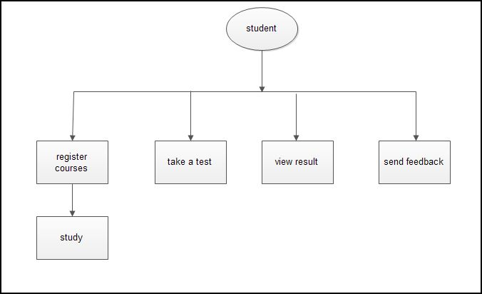

**Fig 1:** The hierarchical diagram of the modules

**Development of system requirements**

At this stage, the requirements for this system were developed. These include the output requirements, input requirements, and file and storage requirements.

**Output Requirements**

The logical place to begin a detailed study of the output requirements and the design of the entire system is the output. Since the application is meant to display students’ course record and details, the output display is designed in such a way that is user-friendly i.e self-explanatory.

**Input Requirement**

* Student data
* Lecturer details
* Course details

In order to produce the required output, the input necessary for the output was specified and designed. There are guides on the display, which assist users to know the appropriate steps to be taken to initiate and effect actions to trigger an activity.

**File and storage requirements**

The description of the data storage of the system was specified. This includes contents, organizations, formats, sizes and location of all files this system will use.

**Flow Chart**

The flow diagram also shows how different modules relate with one another. The diagram is as follows:

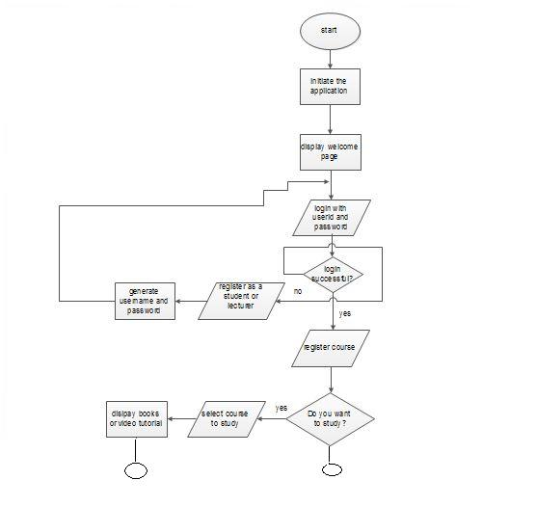

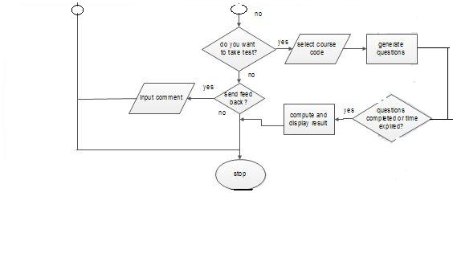

**Fig 2:** Flow chart diagram of the project

**DATABASE**

The database, which is to contain an up-to-date record of students, lecturers, courses; were designed with MYSQL. The database contains some tables. In this tables, the fields are defined including the name of the field, the variable type and the length of the variable. MYSQL is case sensitive and so adequate care was taken while entering the fields.

**3.1** **The Exam Session of E-learning Management System:**

The system is consisting of a web server with a database facility. This server is configured with proper security measures. Clients (candidates) can connect through the internet with a web browser (e.g.: Internet Explorer, Mozilla Firefox etc) to the server or locally through the LAN and take the exam. Examiners too can connect to the server through the internet or setting up papers and to do other related tasks.

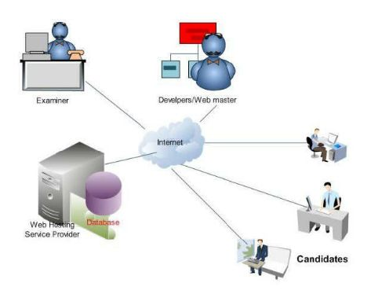

**Fig 3:** The Online Examination Architecture

**3.1.1 Brief description:**

Under this setup, a web hosting facility with server side programming using PHP-MyAdmin and database facility from a web hosting service provider is implemented. Server scripts were written locally using the server scripting language afore mentioned to connect the web server through internet and set up the databases remotely with the obtained server facility.

**3.1.1.1 Registration module**

The registration module handles the data and information of students. The supplied information are collected by creating a friendly easy to employ interactive environment interface, information are handled using the PHP codes and submitted to the database for proper documentations.

**3.1.1.2 Identification Module**

This module authenticates the students’ ID, user name, and password. After the authentication, the student is allowed to proceed to the students interface. In this case, no candidate can register twice as authentication is based on the field required during registration.

**3.1.1.3 The Examination Module**

The traditional approach to measuring a person’s level of knowledge in a topic has been the examination. These days there is often more emphasis on "internal" assessments, which may consist of assignments and projects given out by the lecturer and then marked or assessed by the same lecturer. Examinations have the advantages of:

* Confidence that a large number of students are all being assessed equally.
* Reduced opportunity for cheating.
* Less marking work, where an entire year’s assessment can be made based on the output of students over a 2 or 3 hour period.

This module aims at conducting and evaluating examinations. It provides a centralized database of questions from which the tests will be prepared. The questions are uploaded to the site via the internet, thus maintaining a uniform pattern for all the examinees throughout the organization.

The task of maintaining the record of scores and the tests for each registered candidate as appeared will be done by the result module. The candidate evaluation report can be printed at any point in time by just providing the necessary details as registered. Numerous sets of distinct question papers can then be printed, consisting of all type of questions in equal proportion.

The internet creates opportunities for making examinations both more reliable and cheaper than they already are.

* 1. **A brief description of how the system works:**

1. Applicants (Candidates) apply for the exam online or through internet or intranet, after evaluating the applications
2. Candidates take the exam and submit the answers.
3. After evaluating answers examiner issues result.

The product (system) aims at reducing costs associated with conducting exams over a period of time and achieving total automation of examination system- related tasks like registration, publication of results, which leads to a very high degree of system efficiency.

**3.2.1** **Product Features**

Some basic facilities provided by the system are listed below. Few of them are:

1. In built Question database for exam questions
2. Access anywhere, anytime Application
3. Exam Format intuitive and easy to navigate.
4. Administrators load the books and video tutorials of courses and questions into the database
5. Books, video tutorial and examinations of courses are generated automatically as per student selections
6. Lecturers can also upload required study material and references for test takers.

**Use Case Diagrams**

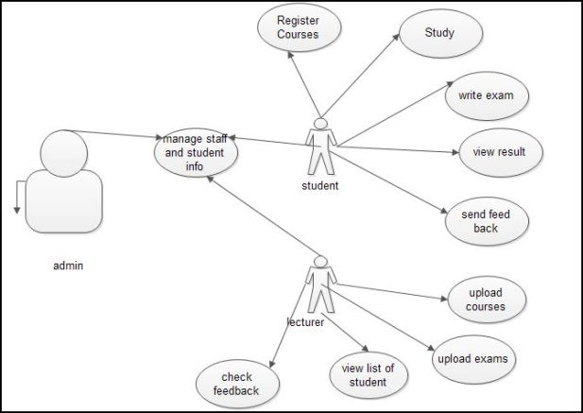

**Fig 4:** use case diagram

**CHAPTER FOUR**

**4.0 RESULT AND DISCUSSION**

The figures below depict the results obtained by the general procedure of the e-learning and online examination system as proposed in the previous chapter. Any student that is not registered through the Admin will not be eligible to take Test and the lecture and also Any candidate that is not eligible is automatically disallowed from downloading the instructors lecture note and taking the examination. The moment a candidate’s eligibility is verified, a candidate thus has an access to study or take a test. To study the candidate is to select from the list of courses that are made available by the lecturers. A candidate can decide to study via books uploaded or video tutorial. For the test, questions are generated from the database and displayed for such applicant and the examination continues until the applicant finishes not later than the stipulated time for the examination. At the end of the examination, the student submits his/her work and the system automatically computes the result and displays it for the students.

**4.1 Secure Login**

The first and probably most significant feature is the Secure Logon. When the application is first called up, the only thing that is viewable is a screen with a button that allows the Admin to login.

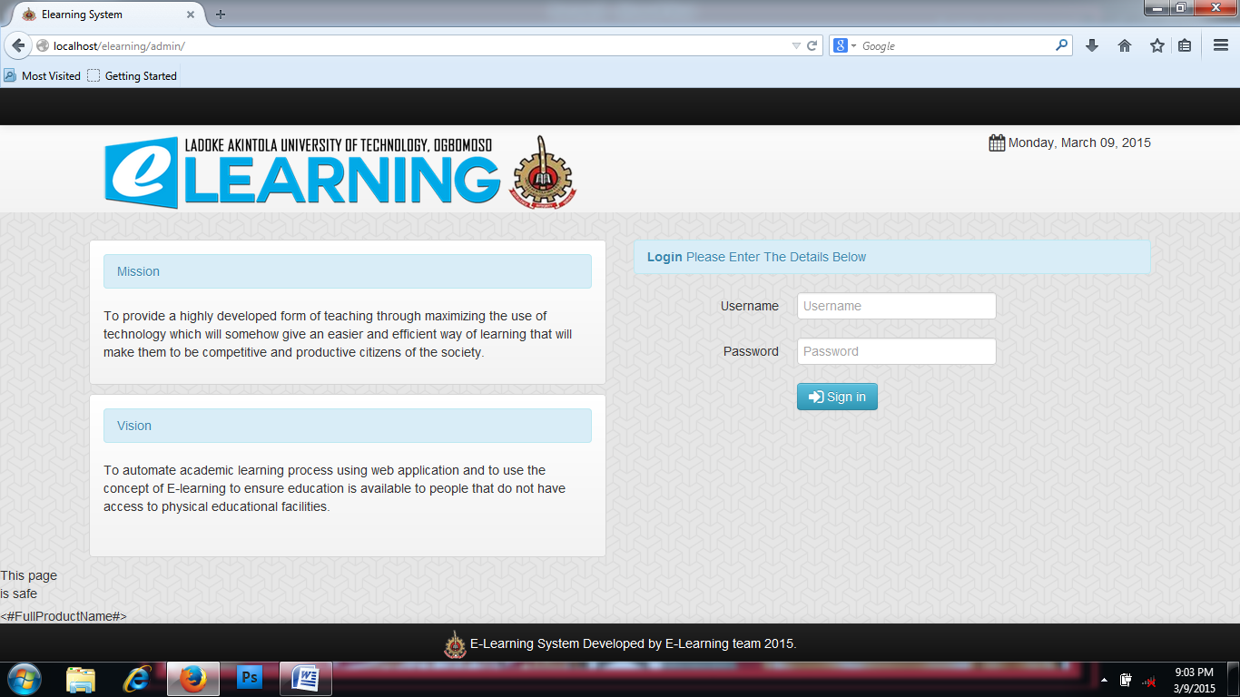

**Figure 5:**  Secure login interface

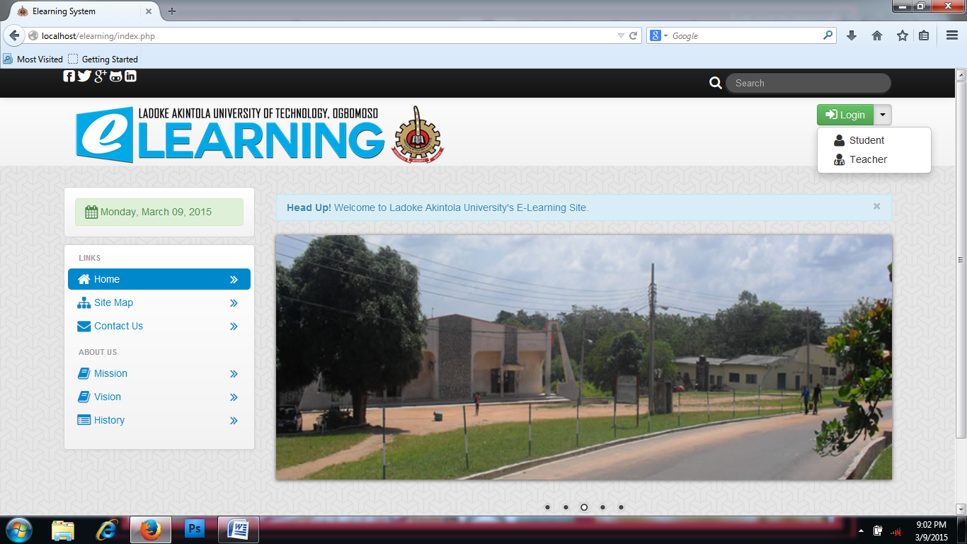

**Figure 6:** Login interface

This Figures shows the login interface for student and Teachers, Lecturers or Instructors.

Security was one of the most important concerns to us since student’s grades and instructors grading abilities are extremely important and must be kept free from outside unauthorized access.

**4.1.1 Static Data Storage**

Since the application will be accessed throughout the quarter in which the student is taking the class and in which the teacher is teaching the class, the data records of events must be kept in statically. dynamically making Course Management System successful in maintaining information even in the event of a server crash.

**4.1.2 Upload Resources**

File upload is an important part of the E-learning System application since it enables users to upload files. This feature uses the “pull” information, in which a user is able to upload and download the files stored on the system. E-learning System uses Mysql that secures the file and stores it in the appropriate

folder according to the specific user that is logged in. With the file upload feature the

Admin will be able to upload videos files which can include MPG, MOV, AVI,

MPEG, QTW and QT. The user will also be able to upload image files such as BMP,

GIF, GPG, JPEG, PCX, TIF and PNG. Other types include sounds like AIF, AU, MID,

MIDI, MP4, RA, RAM, RM and WAV. MS PowerPoint presentations, MS Word

documents, MS Excel spreadsheets, MS Access Databases can also be uploaded.

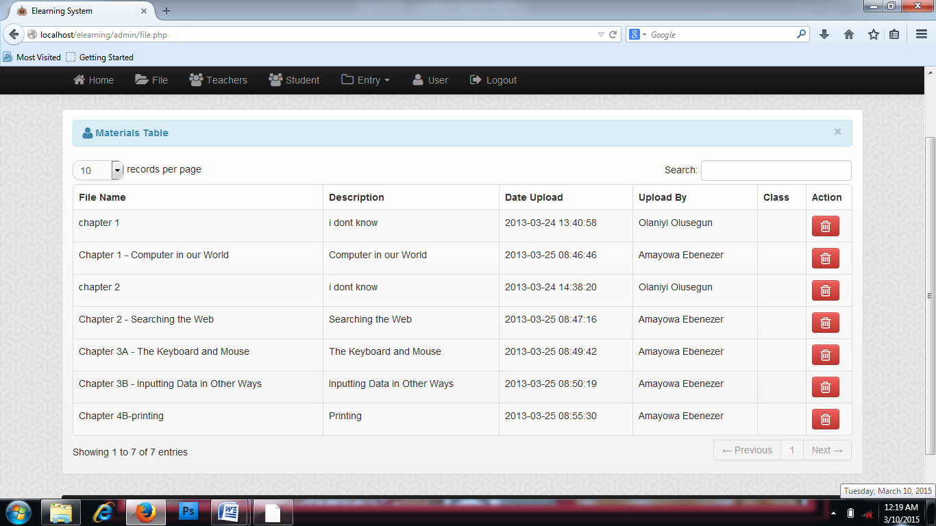

**Figure 7:** Upload resources interface

**4.1.3 Account Management**

E-learning System makes it easy for the users to manage their account. They can edit their profile information using the profile option. They can edit their first name, last name and password. Other account management is done by the Administrator who is in charge of adding and deleting users from the system.

**4.2 Teacher Login**

After the user has logged in at an Instructor level, he/she will have access to the

menu options Notice how the instructor has the ability to add class, add subject, manage students and manage exams.

Another detail to be noted is that the user at an Instructor Level will be able add and delete students from classes.

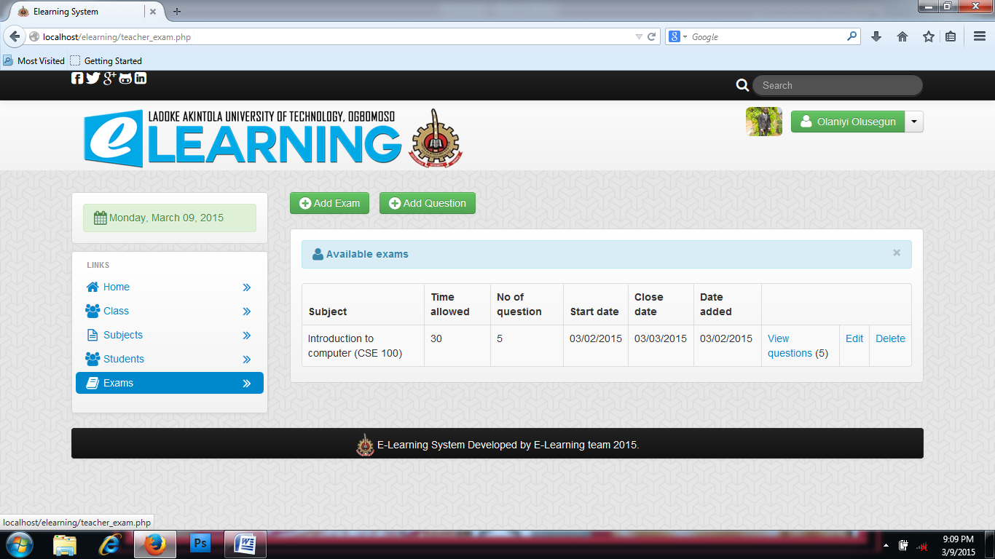

**Figure 8:** Teachers login interface

**4.3 Student Login**

After the user has logged in at a student access level, he will be able to view the class, download the necessary materials uploaded by the instructor , take a test or exams and view the score after submission.

The user level has the least access to the system however the limited access level will not limit or diminish his/her communication ability with the instructor.

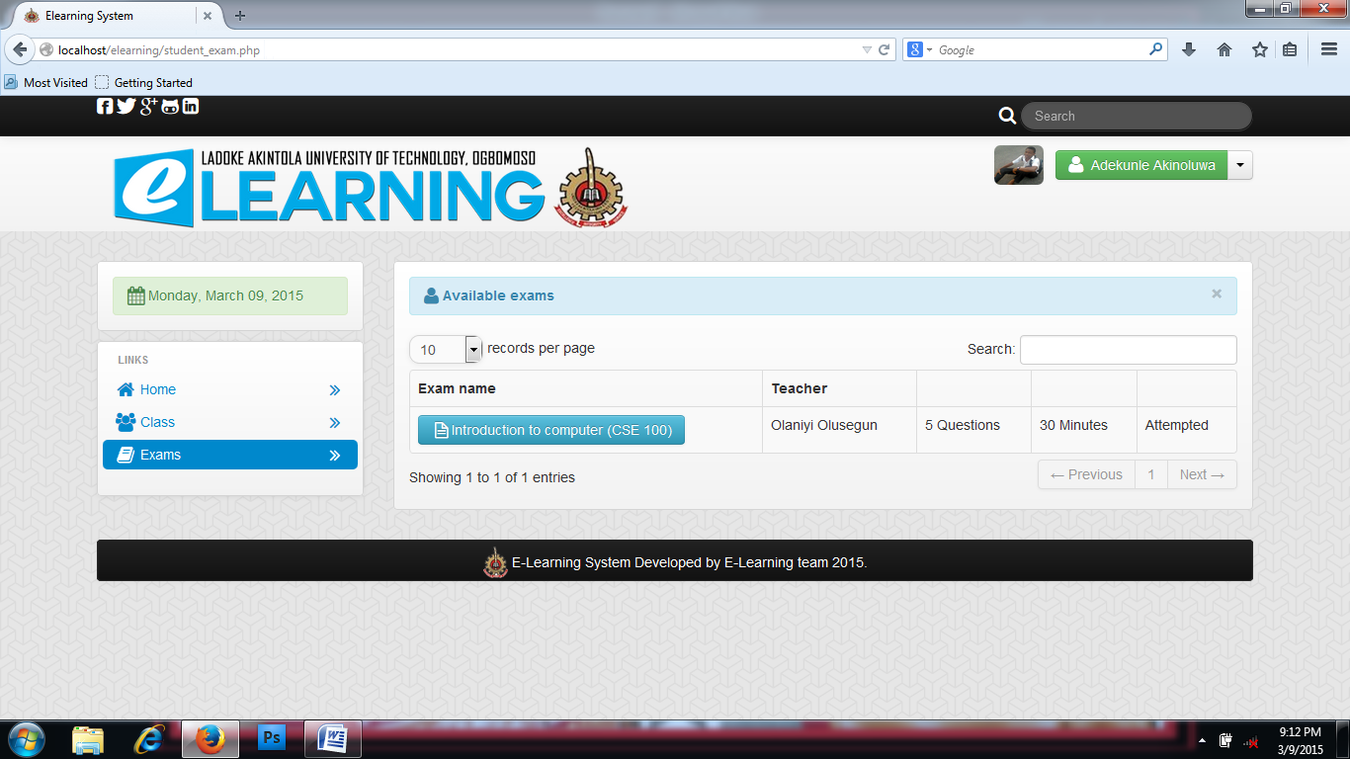

**Figure 9:** Students login interface

**4.4 Admin Login**

This level has the highest level of security. The administrator is in charge of adding and deleting students and instructor’s accounts as well as maintaining the overall user levels and class organization. Having an administrator level user was vital for the maintenance of E-learning System. Since the administrator has the ability to change user levels to all registered users in the class, he/she will be able to basically administer an extra level of security, for this reason the administrator level should be granted in a guarded manner.



**Figure 10:** Admin login interface

**CHAPTER FIVE**

**CONCLUSION AND RECOMMENDATION**

**5.1 CONCLUSION**

With E-learning and online examination system creating central place to store, review and recall all student's performance, which provides easy access to all administrators and staff to integrate data and details collection.

This also aids all the required staff, administrators and teachers come to know of any new student registration instantly with an improved work flow system. Contact details about any student, any class, and results can be viewed, found in a matter of a few seconds.

It can be inferred that this system when properly managed, the chances of loosing bulk of data, misplacement and mismanagement of students results and script, delay in getting information as to who will coordinate a course, where will be the venue for the lecture, how many number of students are to be accountable to and what will be use as materials for the course is not going to pose a huge problem unlike in the traditional mode where there may be greater tendency of encountering such challenges.

This simple and effective learning and examination System has been coded using html, J-querry, BOOTSTRAP, PHP and MYSQL server as the backend.

**5.2 RECOMMENDATION**

Due to the rapid growth and development in the nature of teaching and learning across the globe as technology cannot be sideline, the academic aspect can be enhance by looking into this kind of e-learning and online examination system to improve the quality of assessment of student and lecture mode of lecturers. With this approach, public schools, private schools and training institutes can have a simple, comprehensive and easy to use system for registration of courses and uploading of course materials, assigning of courses to lecturer in charge, student registration and as well as assessment of student performance.

Also, I will want to recommend for the school institutes to create an environment for the effective usage of some similar e-learning system such as electronic communication tools to promote the application and development of e-learning tools and standards to support effective practice.

**References**

Courts, B., and J. Tucker. “Using Technology To Create A Dynamic Classroom Experience. Journal of College Teaching & Learning (TLC),” 9(2), (2012): 121–128.

Ellis, Ryan. “Tracking, Reporting and Delivery of E-learning Education Resources” (2004).

Tavangarian, D, M Leypold, K Nölting, and M Röser. “Is E-learning the Solution for Individual Learning? Journal of E-learning, 2004.” (2004).

Airasian, P. W. & Russell, M. (2007). Classroom assessment: Concepts and applications,(6thed.). New York, NY: McGraw-Hill.

Russell, M., Hoffmann, T., & Higgins, J. (2009). Nimble Tools: A universally designed test delivery system. Teaching Exceptional Children, 42(2).

Carey, R, and (first). “Online Courses for Math Teachers : Comparing Self-faced and Facilitated Cohort Approach.” (n.d.).

Courts, B., and J. Tucker. “Using Technology To Create A Dynamic Classroom Experience. Journal of College Teaching & Learning (TLC),” 9(2), (2012): 121–128.

Ellis, Ryan. “Tracking, Reporting and Delivery of E-learning Education Resources” (2004).

Tavangarian, D, M Leypold, K Nölting, and M Röser. “Is E-learning the Solution for Individual Learning? Journal of E-learning, 2004.” (2004).

Carey, R., Kleiman, G., Russell, M., & Venable, J. D. (2008). Online courses for math teachers: Comparing self-faced and facilitated cohort approach.

INDEX

<?php include('header.php'); ?>

<?php include('session.php'); ?>

<body>

<div class="row-fluid">

<div class="span12">

<?php include('navbar.php'); ?>

<div class="container">

<div class="row-fluid">

<div class="span2">

<!-- left nav -->

<ul class="nav nav-tabs nav-stacked">

<li class="active">

<a href="add_course.php"><i class="icon-plus-sign-alt icon-large"></i>&nbsp;Add Course</a>

<a href="course.php"><i class="icon-arrow-left icon-large"></i>&nbsp;Back</a>

</li>

</ul>

<!-- right nav -->

<div class="span10">

<div class="hero-unit-3">

<ul class="thumbnails">

<li class="span7">

<div class="thumbnail">

<div class="alert alert-info"><i class="icon-plus-sign-alt icon-large"></i>&nbsp;Add Course Entry</div>

<form class="form-horizontal" method="POST">

<div class="control-group">

<label class="control-label" for="inputPassword">Course Year And Section:</label>

<div class="controls">

<input type="text" name="cc" id="inputPassword" placeholder="Course Year And Section" required>

</div>

<div class="control-group">

<label class="control-label" for="inputPassword">Department:</label>

<div class="controls">

<select name="cd" required>

<option></option>

<?php

$query=mysql_query("select * from department");

while($row=mysql_fetch_array($query)){

?>

<option><?php echo $row['department']; ?></option>

<?php

}

?>

</select>

</div>

<div class="control-group">

<label class="control-label" for="inputPassword">Major:</label>

<div class="controls">

<input type="text" name="major" id="inputPassword" placeholder="Major">

</div>

<div class="control-group">

<div class="controls">

<button type="submit" name="save" class="btn btn-info"><i class="icon-save icon-large"></i>&nbsp;Save Course</button>

</div>

</form>

<?php

if (isset($_POST['save'])) {

$cc = $_POST['cc'];

$cd = $_POST['cd'];

$major = $_POST['major'];

mysql_query("insert into course (cys,department,major) values ('$cc','$cd','$major')") or die(mysql_error());

header('location:course.php');

}

?>

</div>

</li>

</ul>

<?php include('footer.php'); ?>

</div>

</body>

</html>

<?php include('header.php'); ?>

<?php include('session.php'); ?>

<body>

<div class="row-fluid">

<div class="span12">

<?php include('navbar.php'); ?>

<div class="container">

<div class="row-fluid">

<div class="span2">

<!-- left nav -->

<ul class="nav nav-tabs nav-stacked">

<li class="active">

<a href="add_department.php"><i class="icon-plus-sign-alt icon-large"></i>&nbsp;Add Department</a>

<a href="department.php"><i class="icon-arrow-left icon-large"></i>&nbsp;Back</a>

</li>

</ul>

<!-- right nav -->

</div>

<div class="span10">

<div class="hero-unit-3">

<ul class="thumbnails">

<li class="span7">

<div class="thumbnail">

<div class="alert alert-info"><i class="icon-plus-sign-alt icon-large"></i>&nbsp;Add Department Entry</div>

<form class="form-horizontal" method="POST">

<div class="control-group">

<label class="control-label" for="inputPassword">Department:</label>

<div class="controls">

<input type="text" name="d" id="inputPassword" placeholder="Department" required>

</div>

<div class="control-group">

<label class="control-label" for="inputPassword">Person In Charge:</label>

<div class="controls">

<input type="text" name="p" id="inputPassword" placeholder="Person In Charge" required>

</div>

<div class="control-group">

<label class="control-label" for="inputPassword">Title:</label>

<div class="controls">

<input type="text" name="t" id="inputPassword" placeholder="Title" required>

</div>

<div class="control-group">

<div class="controls">

<button type="submit" name="save" class="btn btn-info"><i class="icon-save icon-large"></i>&nbsp;Save Department</button>

</div>

</form>

<?php

if (isset($_POST['save'])) {

$d = $_POST['d'];

$p = $_POST['p'];

$t = $_POST['t'];

mysql_query("insert into department (department,incharge,title) values ('$d','$p','$t')") or die(mysql_error());

header('location:department.php');

}

?>

</li>

</ul>

</div>

<?php include('footer.php'); ?>

</div>

</body>

</html>

<?php include('header.php'); ?>

<?php include('session.php'); ?>

<body>

<div class="row-fluid">

<div class="span12">

<?php include('navbar.php'); ?>

<div class="container">

<div class="row-fluid">

<div class="span12">

<div class="hero-unit-3">

<a href="student.php" class="btn btn-success"><i class="icon-arrow-left icon-large"></i>&nbsp;Back</a>

<br><br>

<form class="form-horizontal" method="POST" enctype="multipart/form-data">

<div class="control-group">

<label class="control-label" for="inputEmail">Username</label>

<div class="controls">

<input type="text" name="un" id="inputEmail" placeholder="Username" required>

</div>

<div class="control-group">

<label class="control-label" for="inputPassword">Password</label>

<div class="controls">

<input type="password" name="p" id="inputPassword" placeholder="Password" required>

</div>

<div class="control-group">

<label class="control-label" for="inputEmail">Firstname</label>

<div class="controls">

<input type="text" name="fn" id="inputEmail" placeholder="Firstname" required>

</div>

<div class="control-group">

<label class="control-label" for="inputEmail">Lastname</label>

<div class="controls">

<input type="text" name="ln" id="inputEmail" placeholder="Lastname" required>

</div>

<div class="control-group">

<label class="control-label" for="inputEmail">Middlename</label>

<div class="controls">

<input type="text" name="mn" id="inputEmail" placeholder="Middlename" required>

</div>

<div class="control-group">

<label class="control-label" for="input01">Image:</label>

<div class="controls">

<input type="file" name="image" class="font" required>

</div>

<div class="control-group">

<div class="controls">

<button type="submit" name="submit" class="btn btn-info"><i class="icon-save icon-large"></i>&nbsp;Save</button>

</div>

</form>

<?php

if (isset($_POST['submit'])) {

$un = $_POST['un'];

$p = $_POST['p'];

$fn = $_POST['fn'];

$ln = $_POST['ln'];

$mn = $_POST['mn'];

$image = addslashes(file_get_contents($_FILES['image']['tmp_name']));

$image_name = addslashes($_FILES['image']['name']);

$image_size = getimagesize($_FILES['image']['tmp_name']);

move_uploaded_file($_FILES["image"]["tmp_name"], "uploads/" . $_FILES["image"]["name"]);

$location = "uploads/" . $_FILES["image"]["name"];

mysql_query("insert into student (username,password,firstname,lastname,middle_name,location)

values ('$un','$p','$fn','$ln','$mn','$location')

") or die(mysql_error());

header('location:student.php');

}

?>

</div>

<?php include('footer.php'); ?>

</div>

</body>

</html>

<?php include('header.php'); ?>

<?php include('session.php'); ?>

<body>

<div class="row-fluid">

<div class="span12">

<?php include('navbar.php'); ?>

<div class="container">

<div class="row-fluid">

<div class="span2">

<!-- left nav -->

<ul class="nav nav-tabs nav-stacked">

<li class="active">

<a href="add_course.php"><i class="icon-plus-sign-alt icon-large"></i>&nbsp;Add Subject</a>

<a href="subject.php"><i class="icon-arrow-left icon-large"></i>&nbsp;Back</a>

</li>

</ul>

<!-- right nav -->

</div>

<div class="span10">

<div class="hero-unit-3">

<ul class="thumbnails">

<li class="span7">

<div class="thumbnail">

<div class="alert alert-info"><i class="icon-plus-sign-alt icon-large"></i>&nbsp;Add Subject Entry</div>

<form class="form-horizontal" method="POST">

<div class="control-group">

<label class="control-label" for="inputPassword">Subject Code:</label>

<div class="controls">

<input type="text" name="sc" id="inputPassword" placeholder="Subject Code" required>

</div>

<div class="control-group">

<label class="control-label" for="inputPassword">Subject Title:</label>

<div class="controls">

<input type="text" name="st" id="inputPassword" placeholder="Subject Title" required>

</div>

<div class="control-group">

<label class="control-label" for="inputPassword">Cateogry:</label>

<div class="controls">

<select name="c" required>

<option></option>

<option>Major</option>

<option>Minor</option>

</select>

</div>

<div class="control-group">

<div class="controls">

<button type="submit" name="save" class="btn btn-info"><i class="icon-save icon-large"></i>&nbsp;Save Subject</button>

</div>

</form>

<?php

if (isset($_POST['save'])) {

$sc = $_POST['sc'];

$st = $_POST['st'];

$category = $_POST['c'];

mysql_query("insert into subject (subject_code,subject_title,category) values ('$sc','$st','$category')") or die(mysql_error());

header('location:subject.php');

}

?>

</li>

</ul>

</div>

<?php include('footer.php'); ?>

</div>

</body>

</html>

<?php include('header.php'); ?>

<?php include('session.php'); ?>

<body>

<div class="row-fluid">

<div class="span12">

<?php include('navbar.php'); ?>

<div class="container">

<div class="row-fluid">

<div class="span2">

<!-- left nav -->

<ul class="nav nav-tabs nav-stacked">

<li class="active">

<a href="add_sy.php"><i class="icon-plus-sign-alt icon-large"></i>&nbsp;Add School Year</a>

<a href="sy.php"><i class="icon-arrow-left icon-large"></i>&nbsp;Back</a>

</li>

</ul>

<!-- right nav -->

</div>

<div class="span10">

<div class="hero-unit-3">

<ul class="thumbnails">

<li class="span7">

<div class="thumbnail">

<div class="alert alert-info"><i class="icon-plus-sign-alt icon-large"></i>Add School Year</div>

<form class="form-horizontal" method="POST">

<div class="control-group">

<label class="control-label" for="inputPassword">School Year:</label>

<div class="controls">

<input type="text" name="sy" id="inputPassword" placeholder="School Year" required>

</div>

<div class="control-group">

<div class="controls">

<button type="submit" name="save" class="btn btn-info"><i class="icon-save icon-large"></i>&nbsp;Save School Year</button>

</div>

</form>

<?php

if (isset($_POST['save'])) {

$sy = $_POST['sy'];

mysql_query("insert into sy (sy) values ('$sy')") or die(mysql_error());

header('location:sy.php');

}

?>

</li>

</ul>

</div>

</div>

<?php include('footer.php'); ?>

</body>

</html>

<?php include('header.php'); ?>

<?php include('session.php'); ?>

<body>

<div class="row-fluid">

<div class="span12">

<?php include('navbar.php'); ?>

<div class="container">

<div class="row-fluid">

<div class="span12">

<div class="hero-unit-3">

<a href="teacher.php" class="btn btn-success"><i class="icon-arrow-left icon-large"></i>&nbsp;Back</a>

<br>

<form class="form-horizontal" method="post" enctype="multipart/form-data">

<div class="control-group">

<label class="control-label" for="inputEmail">Username</label>

<div class="controls">

<input type="text" id="inputEmail" name="username" placeholder="Username" required>

</div>

<div class="control-group">

<label class="control-label" for="inputPassword">Password</label>

<div class="controls">

<input type="text" name="password" id="inputPassword" placeholder="Password" required>

</div>

<div class="control-group">

<label class="control-label" for="inputEmail">Firstname</label>

<div class="controls">

<input type="text" id="inputEmail" name="firstname" placeholder="Firstname" required>

</div>

<div class="control-group">

<label class="control-label" for="inputEmail">Lastname</label>

<div class="controls">

<input type="text" id="inputEmail" name="lastname" placeholder="Lastname" required>

</div>

<div class="control-group">

<label class="control-label" for="inputEmail">Middlename</label>

<div class="controls">

<input type="text" id="inputEmail" name="middlename" placeholder="Middlename" required>

</div>

<div class="control-group">

<label class="control-label" for="input01">Image:</label>

<div class="controls">

<input type="file" name="image" class="font" required>

</div>

<div class="control-group">

<label class="control-label" for="inputPassword">Department:</label>

<div class="controls">

<select name="department" class="span4" required>

<option></option>

<?php

$query = mysql_query("select * from department");

while ($row = mysql_fetch_array($query)) {

?>

<option><?php echo $row['department']; ?></option>

<?php

}

?>

</select>

</div>

<div class="control-group">

<div class="controls">

<button type="submit" name="save" class="btn btn-info"><i class="icon-save icon-large"></i>&nbsp;Save</button>

</form>

<?php

if (isset($_POST['save'])) {

$username = $_POST['username'];

$password = $_POST['password'];

$firstname = $_POST['firstname'];

$lastname = $_POST['lastname'];

$middlename = $_POST['middlename'];

$department = $_POST['department'];

$image = addslashes(file_get_contents($_FILES['image']['tmp_name']));

$image_name = addslashes($_FILES['image']['name']);

$image_size = getimagesize($_FILES['image']['tmp_name']);

move_uploaded_file($_FILES["image"]["tmp_name"], "uploads/" . $_FILES["image"]["name"]);

$location = "uploads/" . $_FILES["image"]["name"];

mysql_query("insert into teacher (username,password,firstname,lastname,middlename,department,location)

('$username','$password','$firstname','$lastname','$middlename','$department','$location')

") or die(mysql_error());

header('location:teacher.php');

}

?>